Date: 20-11-2025
Roll No: CB.EN.U4CCE23062
RESPONSIVE HTML
Responsive web design means creating web pages that work properly on every device and screen size.
A responsive website automatically adjusts its layout based on the screen width and viewport size so that users get a good experience on mobile, tablet, and desktop.
What is Responsive Web Design?
Responsive Web Design is the approach of using HTML and CSS techniques to adapt a webpage by resizing, rearranging, hiding, shrinking, or expanding content so that the website looks clean and readable on different devices such as desktops, tablets, and smartphones.

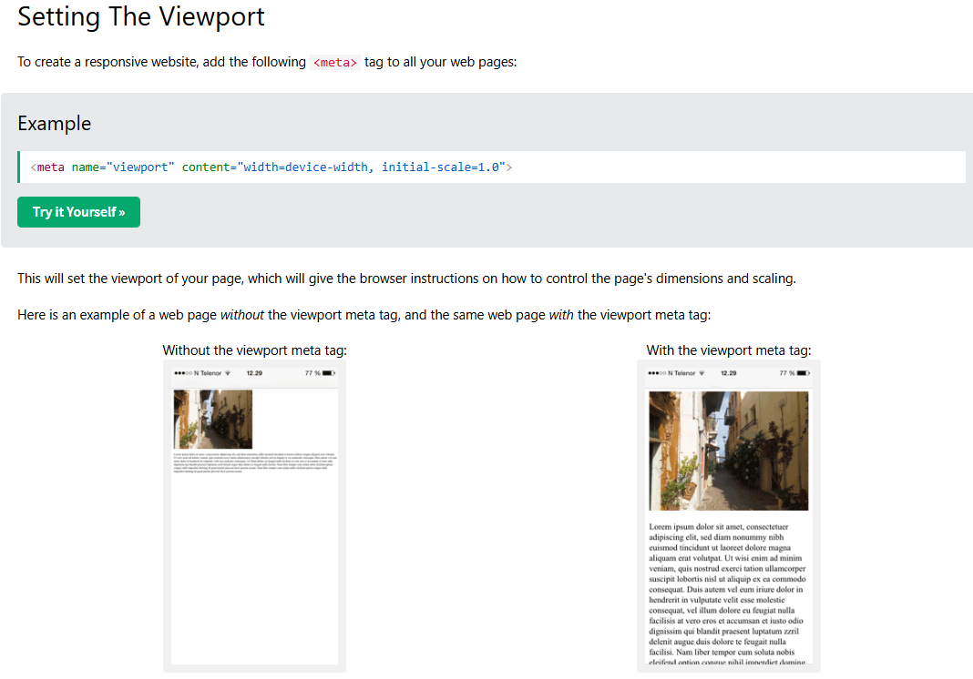

With <picture> tag
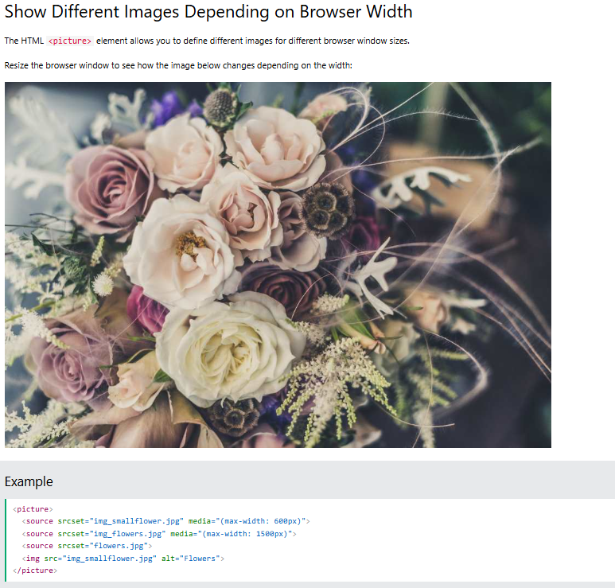

Responsive Text Size
The text size can be set with a "vw" unit, which means the "viewport width".
That way the text size will follow the size of the browser window:
<h1 style="font-size:10vw">Hello World</h1>

Media Queries
